**Air Cargo Analysis**

**1. Total revenue in business class:**

**C:\Users\USer\OneDrive\Pictures\Screenshots\a sql\Screenshot (131).png**

**Output:**

**C:\Users\USer\OneDrive\Pictures\Screenshots\a sql\Screenshot (133).png**

**2.** **Customers who have registered and booked a ticket:**

**C:\Users\USer\OneDrive\Pictures\Screenshots\Screenshot (134).png**

**Output:**

**C:\Users\USer\OneDrive\Pictures\Screenshots\a sql\Screenshot (132).png**

**3.Customer’s name based on their customer id and brand(Emirates):**

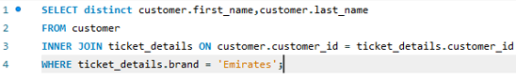

**Output:**

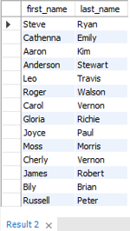

**4.** **Displaying the full name of the customer:**

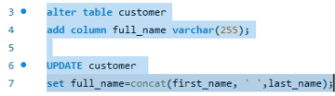

**Output:**

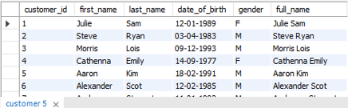

**5.** **Number of passengers and total revenue in business class:**

**C:\Users\USer\OneDrive\Pictures\Screenshots\Screenshot (141).png**

**Output:**

**C:\Users\USer\OneDrive\Pictures\Screenshots\Screenshot (142).png**